NDVI-Based Crop Health Monitoring of Faisalabad District
QGIS & Remote Sensing Project using Sentinel-2 MSI Data

1. Project Overview
This project assesses vegetation and crop health across Faisalabad District, Punjab, Pakistan, using Sentinel-2 MSI imagery and the Normalized Difference Vegetation Index (NDVI). QGIS supported raster processing, spatial analysis, classification, area calculation, and thematic map production.

2. Study Area
The study area is Faisalabad District, Punjab, Pakistan. The Faisalabad district boundary was obtained from the geoBoundaries Pakistan ADM2 dataset and used to define the project study area.

3. Objective
The main objective was to use NDVI to assess the spatial distribution of vegetation density and crop-health conditions across Faisalabad District and present the results in a clear thematic map.

4. Data Sources
- Sentinel-2 MSI imagery, including the B04 Red band and B08 Near-Infrared (NIR) band, was used to calculate NDVI and assess vegetation and crop health across Faisalabad District.
- GeoBoundaries Pakistan ADM2 district boundary data in GeoJSON format was used to define the Faisalabad District study area and clip the NDVI data to the district boundary.

5. Methodology
1. Prepared Sentinel-2 Red (B04) and Near-Infrared (B08) raster data for NDVI analysis.
2. Generated and clipped the NDVI raster to the Faisalabad District study area.
3. Reprojected the NDVI raster to WGS 84 / UTM Zone 43N (EPSG:32643) for projected spatial analysis.
4. Classified the NDVI raster into four classes using the project classification ranges.
5. Calculated pixel counts and area statistics for each NDVI class.
6. Designed the final thematic map in QGIS with a legend, study-area information, methodology, interpretation, and key findings.

6. NDVI Classification
Class | NDVI Range | Pixels | Area (km²) | Percentage
Very Low NDVI | -0.5549 to -0.1662 | 13 | 1.90 | 0.03%
Low NDVI | -0.1662 to 0.2225 | 3,953 | 57.68 | 10.08%
Moderate NDVI | 0.2225 to 0.6113 | 27,373 | 399.40 | 69.82%
High NDVI | 0.6113 to 1.0000 | 7,966 | 116.23 | 20.32%
Total | — | 39,305 | 573.50 | 100%

7. NDVI Interpretation
- Very Low NDVI: Bare soil, built-up areas, water, or very sparse vegetation.
- Low NDVI: Sparse or stressed vegetation with limited crop cover.
- Moderate NDVI: Moderate vegetation and crop cover, indicating generally healthy vegetation.
- High NDVI: Dense and healthy vegetation with strong crop cover.

8. Results and Key Findings
Moderate NDVI areas covered the largest share of the classified area, accounting for 69.82% (399.40 km²). High NDVI areas accounted for 20.32% (116.23 km²), while Low NDVI areas accounted for 10.08% (57.68 km²). Very Low NDVI represented only 0.03% (1.90 km²) of the classified area.

9. Final Map
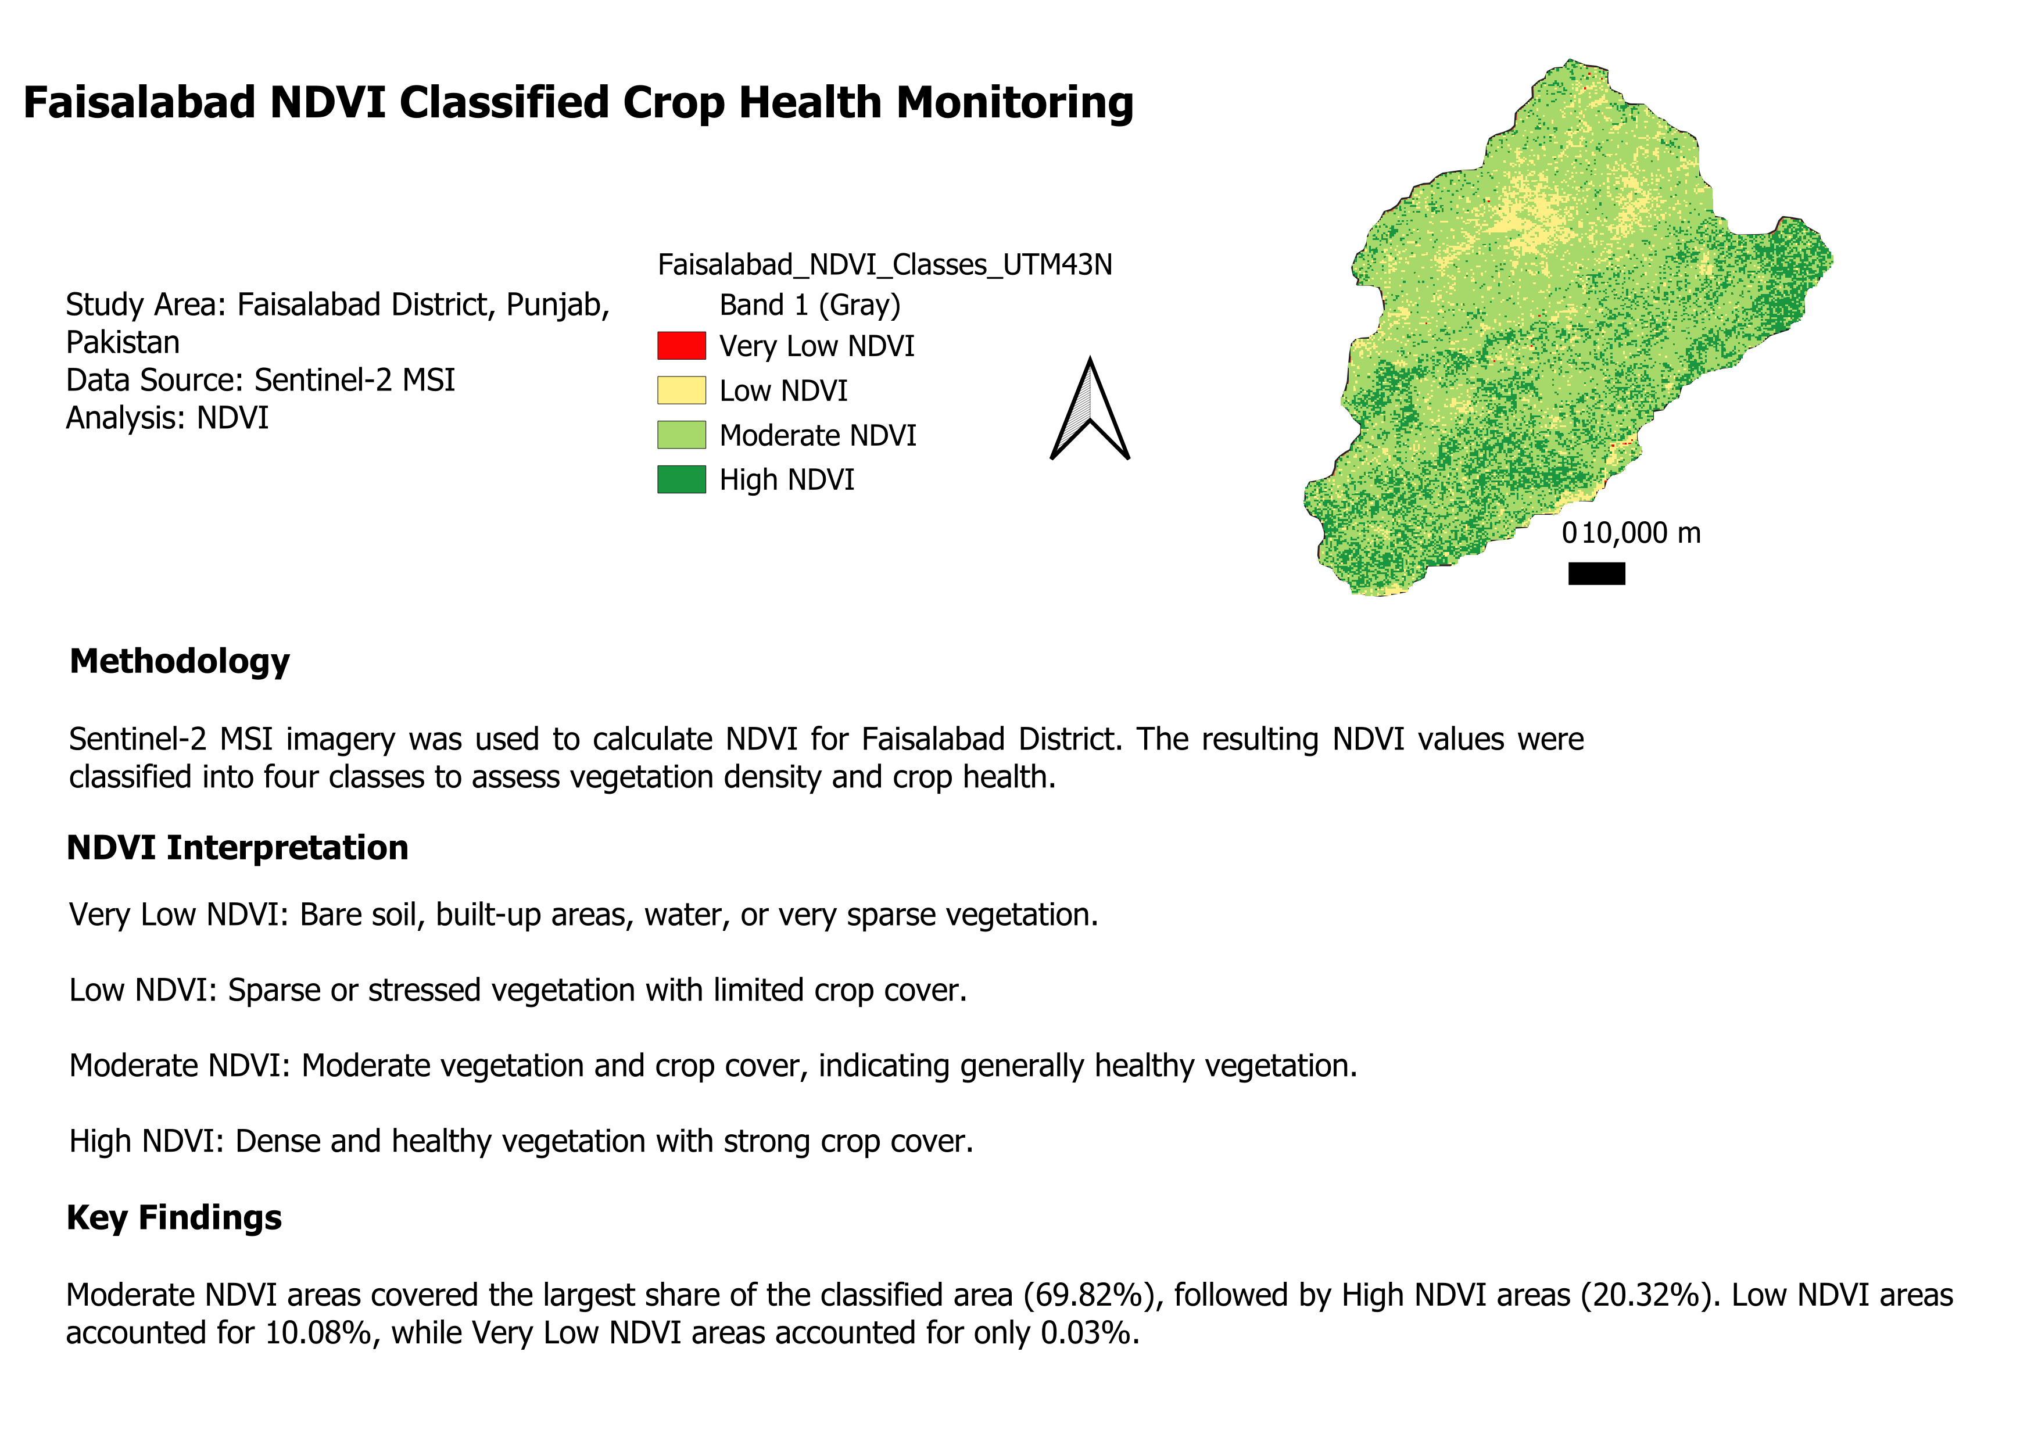
Figure 1: NDVI-based crop health classification map of Faisalabad District.

10. Software and Skills Used
- QGIS
- Remote Sensing
- Sentinel-2 MSI
- NDVI analysis
- Raster Calculator
- Raster reprojection
- Raster classification
- Spatial and area analysis
- Thematic cartography

11. Project Outputs
- Processed NDVI raster datasets.
- Four-class NDVI classification raster.
- NDVI class area statistics.
- Final NDVI and classified crop-health maps in PDF/PNG format.
- QGIS project file documenting the analysis workflow.

12. Conclusion
The project demonstrates a practical remote-sensing workflow for assessing vegetation and crop-health conditions using Sentinel-2 imagery, NDVI, and QGIS. The analysis identified Moderate NDVI as the dominant class across the classified study area, while the final thematic map provides a clear spatial representation of vegetation conditions in Faisalabad District.

